**Common Java Setup Problems**

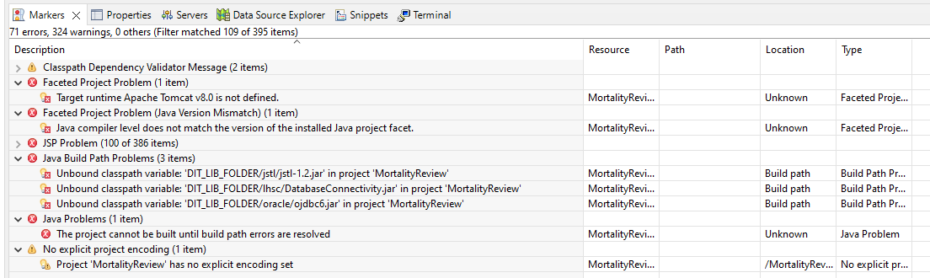

**Faceted Project Problem – Targeted Runtime Apache Not Defined**

* [Project facets - IBM Documentation](https://www.ibm.com/docs/en/radfws/9.6?topic=SSRTLW_9.6.0/com.ibm.javaee.doc/topics/cfacets.htm)
* A facet is a unit of functionality
* Facets define characteristics and requirements for Java EE projects and are used as part of the runtime configuration
* When you add a facet to a project, that project is configured to perform a certain task, fulfill certain requirements, or have certain characteristics
* E.G. EAR facet sets up a project to function as an enterprise application by adding a deployment descriptor
* [Eclipse - Target runtime Apache Tomcat v7.0 is not defined - Stack Overflow](https://stackoverflow.com/questions/37698738/eclipse-target-runtime-apache-tomcat-v7-0-is-not-defined)
* The targeted runtime settings specify the application server and its version level of where you intend to run the project
* [Migrating projects with a different targeted runtime into the workbench - IBM Documentation](https://www.ibm.com/docs/en/wasdtfe?topic=server-migrating-projects-different-targeted-runtime-into-workbench)
* [What is the JRE (Java Runtime Environment)? | IBM](https://www.ibm.com/cloud/learn/jre)
* The Java Runtime Environment, or JRE, is a software layer that runs on top of a computer’s operating system software and provides the class libraries and other resources that a specific [Java](https://www.ibm.com/cloud/learn/java-explained) program needs to run.
* The JRE is one of three interrelated components for developing and running Java programs. The other two components are as follows:
* The[*Java Development Kit*, or *JDK*](https://www.ibm.com/cloud/support-for-runtimes), is a set of tools for developing Java applications. Developers choose JDKs by Java version and by package or edition—Java Enterprise Edition (Java EE), Java Special Edition (Java SE), or Java Mobile Edition (Java ME). Every JDK always includes a compatible JRE, because running a Java program is part of the process of developing a Java program.
* The *Java Virtual Machine*, or *JVM***,** executes live Java applications. Every JRE includes a default JRE, but developers are free to choose another that meets the specific resource needs of their applications.
* The JRE combines Java code created using the JDK with the necessary libraries required to run it on a JVM and then creates an instance of the JVM that executes the resulting program. JVMs are available for multiple operating systems, and programs created with the JRE will run on all of them. In this way, the Java Runtime Environment is what enables a Java program to run in any operating system without modification
* [java - Where would I find and how would I fix my .classpath file - Stack Overflow](https://stackoverflow.com/questions/42071367/where-would-i-find-and-how-would-i-fix-my-classpath-file)
* The classpath shows the path to the JDK and Runtime Environment
* [4.8. Selecting the Java Runtime for Builds - Eclipse Cookbook [Book] (oreilly.com)](https://www.oreilly.com/library/view/eclipse-cookbook/0596007108/ch04s09.html#:~:text=To%20set%20a%20project%2Dspecific,select%20a%20project%2Dspecific%20JRE.)
* **Summary**: The targeted runtime wasn’t defined. Presumably the targeted execution environment was created with the project, but I didn’t have a specific runtime defined on my local machine
* Creating new Java Project:

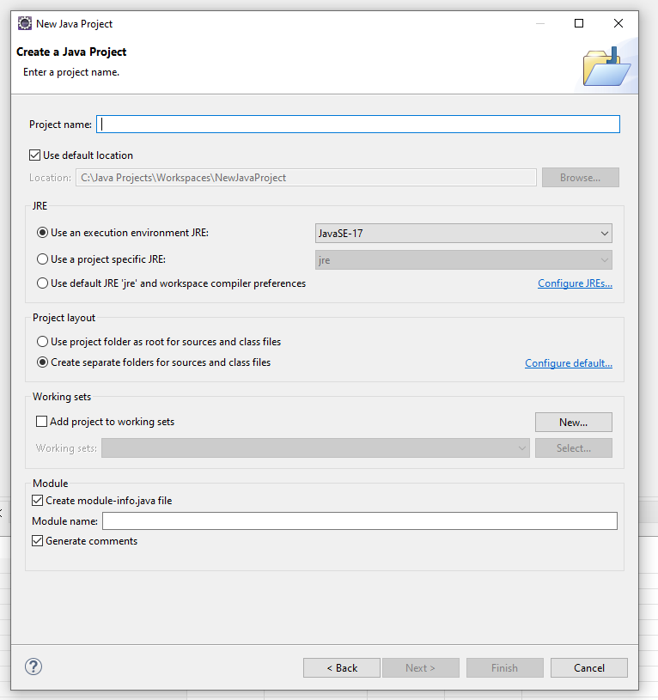

* It looks like you setup the java runtime environment when you create a new project, which would be associated with the project
* [Execution Environments - Eclipsepedia](https://wiki.eclipse.org/Execution_Environments)
* An execution environment isn’t a specific JRE with a specific path location, it’s a configuration in Eclipse that would be associated with a targeted runtime
* Why choose different runtime versions: [Java Versions and Features (marcobehler.com)](https://www.marcobehler.com/guides/a-guide-to-java-versions-and-features)

**Faceted Project Problem (Java Version Mismatch)**

* [eclipse - "Faceted Project Problem (Java Version Mismatch)" error message - Stack Overflow](https://stackoverflow.com/questions/2239959/faceted-project-problem-java-version-mismatch-error-message#:~:text=The%20Java%20facet%20version%20needs,eclipse.)
* [[Fixed] Eclipse - Java compiler level does not match the version of the installed Java project facet | DigitalOcean](https://www.digitalocean.com/community/tutorials/eclipse-java-compiler-level-does-not-match-the-version-of-the-installed-java-project-facet)
* The java facet version always needs to match the java compiler compliance level
* [What is difference between Project level "Java Compiler" and Windows Preferences level "Java"->"Compiler" in Eclipse? - Stack Overflow](https://stackoverflow.com/questions/52764144/what-is-difference-between-project-level-java-compiler-and-windows-preferences)
* Windows -> Preferences sets workspace default settings
* Project -> Properties will set project specific settings that may be used instead of the workspace defaults
* From Jason: if you compile to a higher version than is on the servers it can cause a problem
* We use 1.8 across the projects to be consistent
* Can avoid pushing compiler level with gitignore

**Java Build Path Problems: Unbound Classpath Variable**

* It sounds like it means we have a classpath variable that isn’t pointed at the correct folder structure or classes
* Point to the DIT_LIB_FOLDER directory on local machine